Lab Report

Title: Examining Puerto Rico’s Forest Transition with Spatial Statistics

Notice: Dr. Bryan Runck

Author: Mattie Gisselbeck

Date: November 9, 2022

Repository: <https://github.com/mgisselbeck/GIS5571>

Time Spent: 40 hours

## Abstract

Between 1950 and 1990, Puerto Rico saw a dramatic shift in forest cover which reverted 9 to 37 percent of the island's land area back to forest cover (Rudel et al., 2004). This phenomena, Forest Transition Theory, is believed to have happened because of rural-to-urban migration, land abandonment, non-farm labor markets, and other environmental factors. In the early 1950s, Puerto Rico saw a decline in forest cover due large sums of previously forested land being transitioned to agriculture land for crop export. Overtime, natural disasters tied with over-farming led to decreases in soil viability; furthermore, changing markets caused a loss of income and livelihood for many families and individuals (Rudel et al., 2000). This agriculture shift Puerto Rico saw not only cause major rainforest loss, but also contributed to: (a) less fertile soils, (b) less product demand, (c) loss of export market, and (d) erosion and rain-washed communities.

## Problem Statement

The objective of this research was to identify which of the factors thought to be contributing to forest transition are most significant and can predict forest cover given the explanatory variables. Explanatory variables analyzed include slope, soil productivity, precipitation, poverty rate, population density, and land protection level.

|  |  |  |  |  |  |  |
| --- | --- | --- | --- | --- | --- | --- |
| **#** | **Requirement** | **Defined As** | **(Spatial) Data** | **Attribute Data** | **Dataset** | **Preparation** |
| 1 | Puerto Rico Fishnet (1 km) | Fishnet, Puerto Rico (1 km) | .shp (Vector) | Slope, Precipitation, Tree Cover, Population Density, Poverty, Settlement | Esri – University of St. Thomas | ETL |
| 2 | Puerto Rico Fishnet (5 km) | Fishnet, Puerto Rico (5 km) | .shp (Vector) | Slope, Precipitation, Tree Cover, Population Density, Poverty, Settlement | Esri – University of St. Thomas | ETL |

*Table 1. Required Data*

## Input Data

The table below is a collection of data from Esri and the U.S. Forest Service. Data was scraped through an ETL in ArcGIS Pro via a Python notebook.

|  |  |  |  |
| --- | --- | --- | --- |
| **#** | **Title** | **Purpose in Analysis** | **Link to Source** |
| 1 | Puerto Rico Fishnet (1 km) | This will used to calculate | Esri – University of St. Thomas |
| 2 | Puerto Rico Fishnet (5 km) | This will used to calculate | Esri – University of St. Thomas |
| 3 |  |  | U.S. Forest Service |

*Table 2. Input Data*

## Methods

A 1-km and 5-km scale were used to assess the influence of explanatory variables on the Puerto Rico’s Forest cover. Spatial Autocorrelation (Global Moran's), Hot Spot Analysis, Generalized Linear Regression, and Geographically Weighted Regression tools were used to determine an optimal model and resulting significance for forest cover.

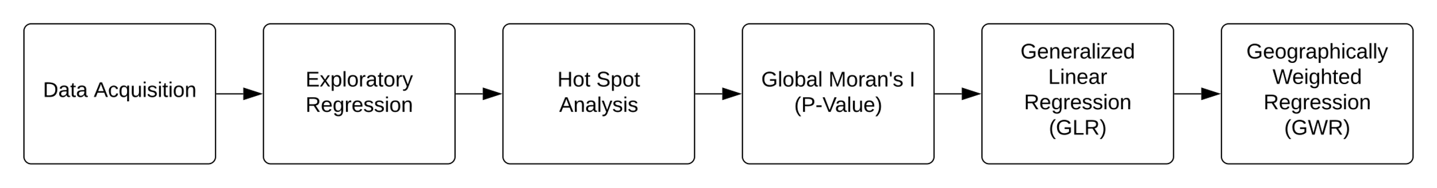

*Figure 1. Forest Transition Model (1 km) – Data Flow Diagram.*

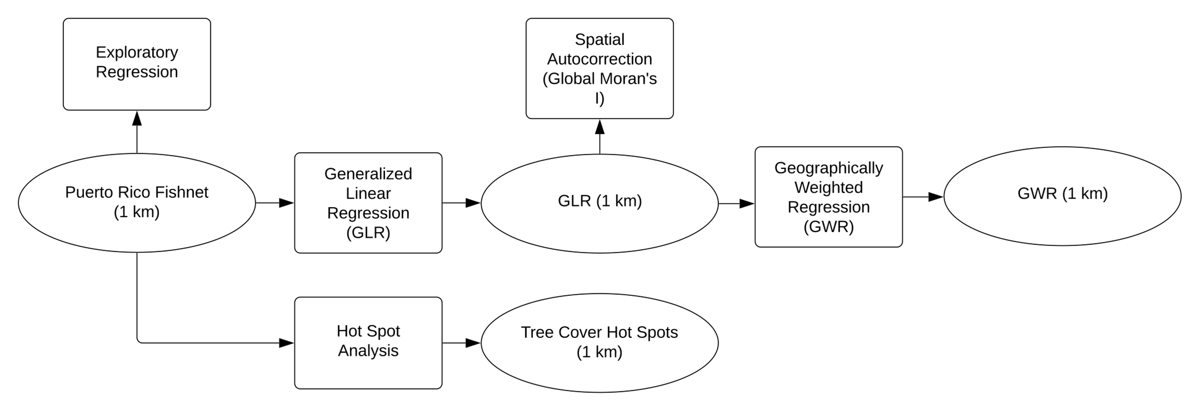

*Figure 2. Forest Transition Model (1 km) – Data Flow Diagram.*

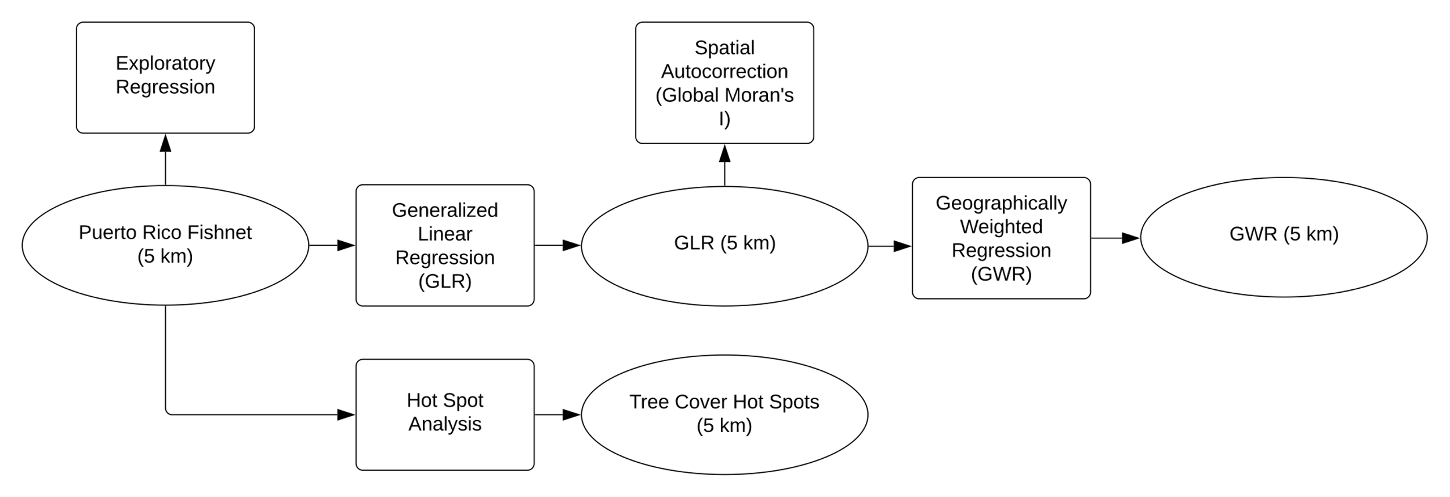

*Figure 3. Forest Transition Model (5 km) – Data Flow Diagram.*

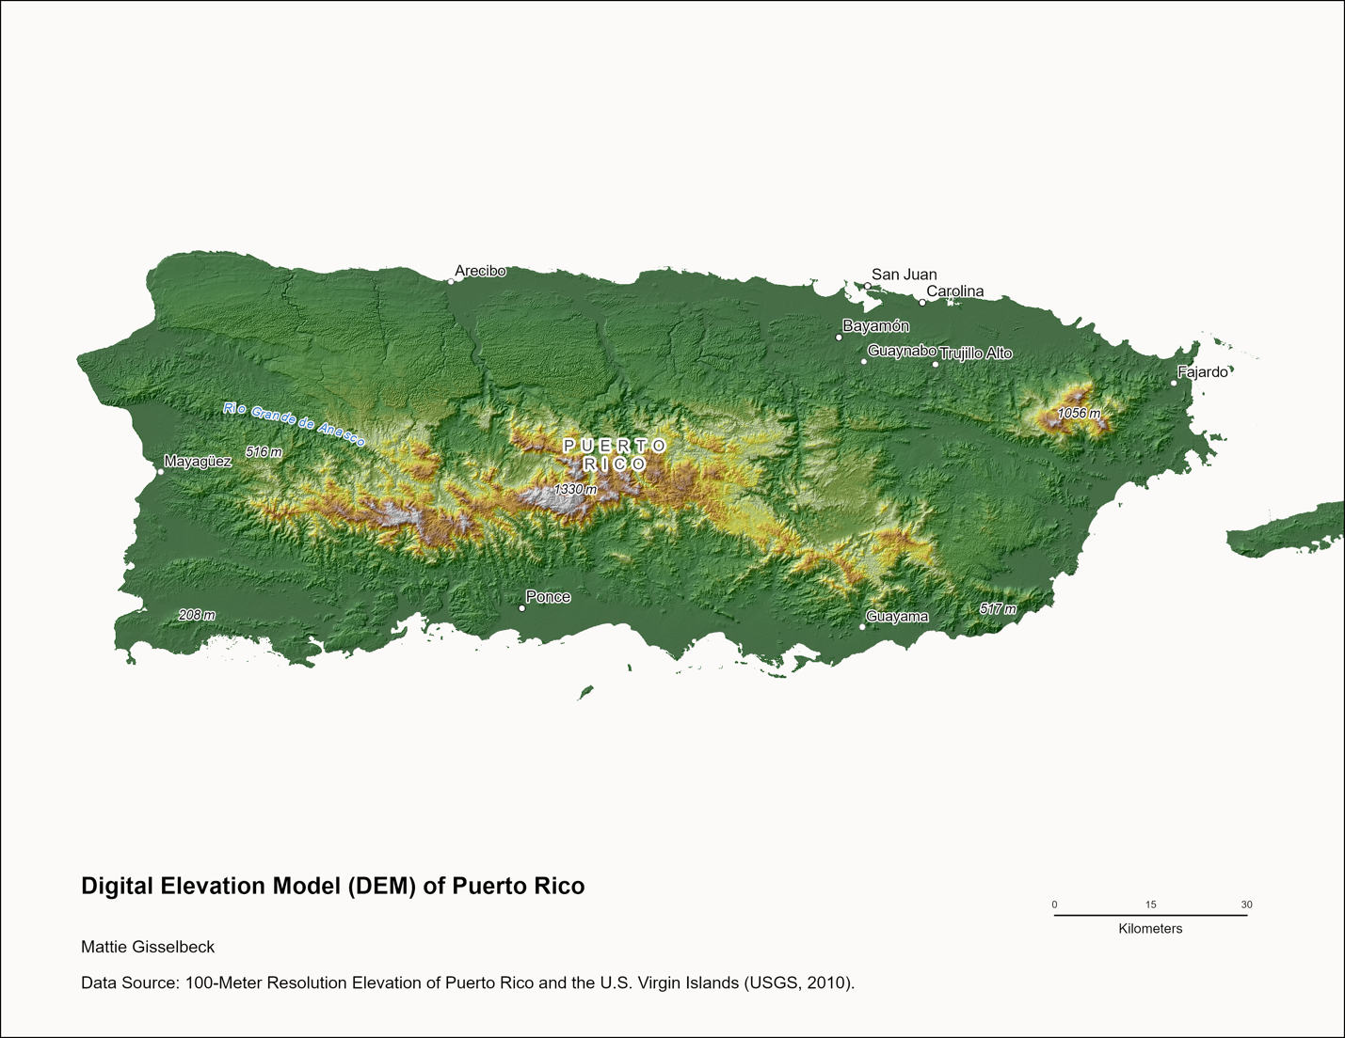

*Figure 4. Digital Elevation Model of Puerto Rico (1:750,000).*

Figure 5. Precipitation of Puerto Rico – 1 km.

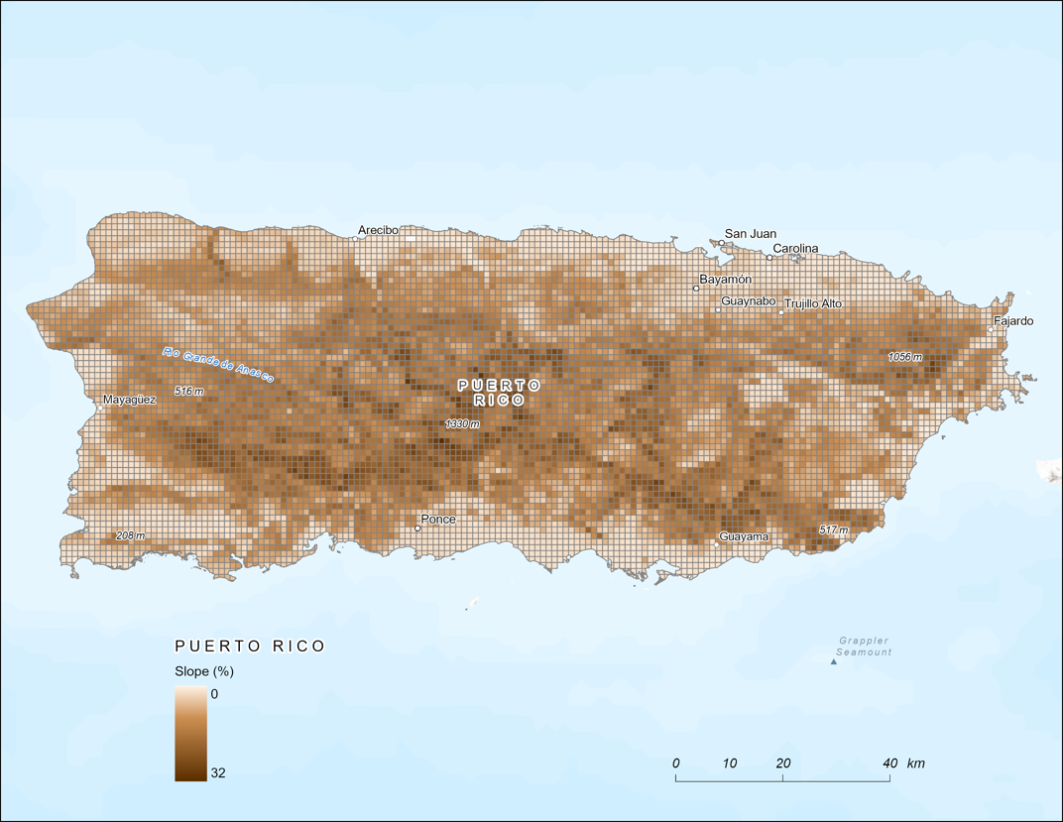

Figure 6. Slope of Puerto Rico – 1 km.

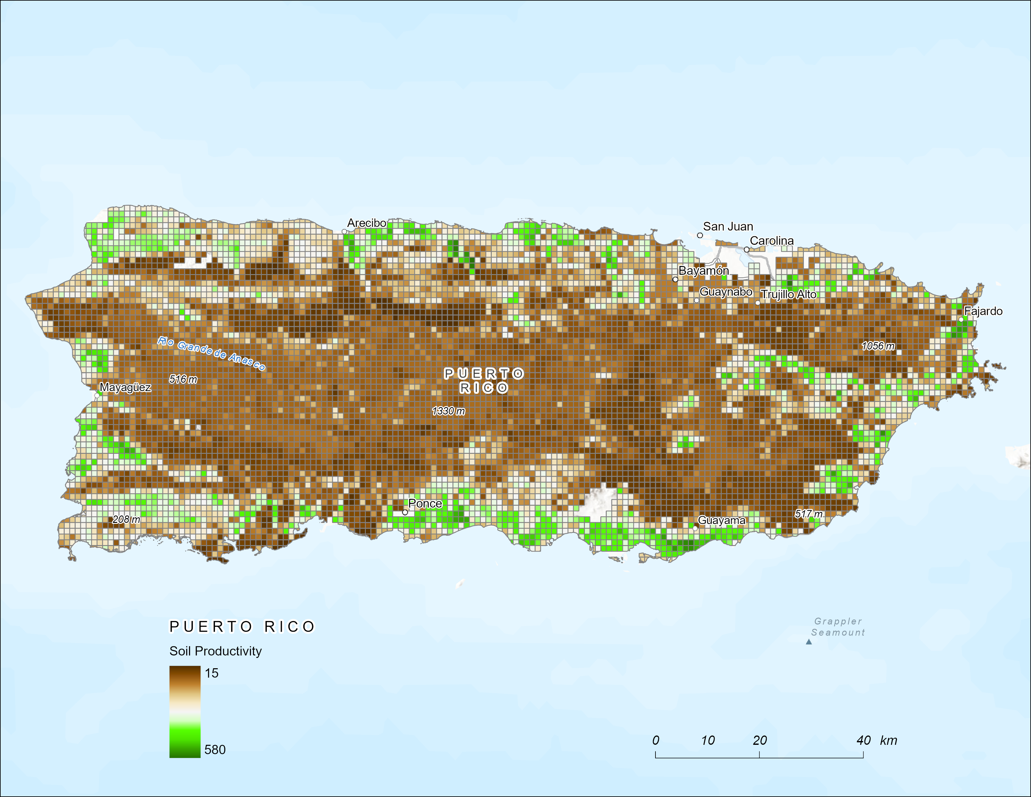

Figure 7. Soil Productivity of Puerto Rico – 1 km.

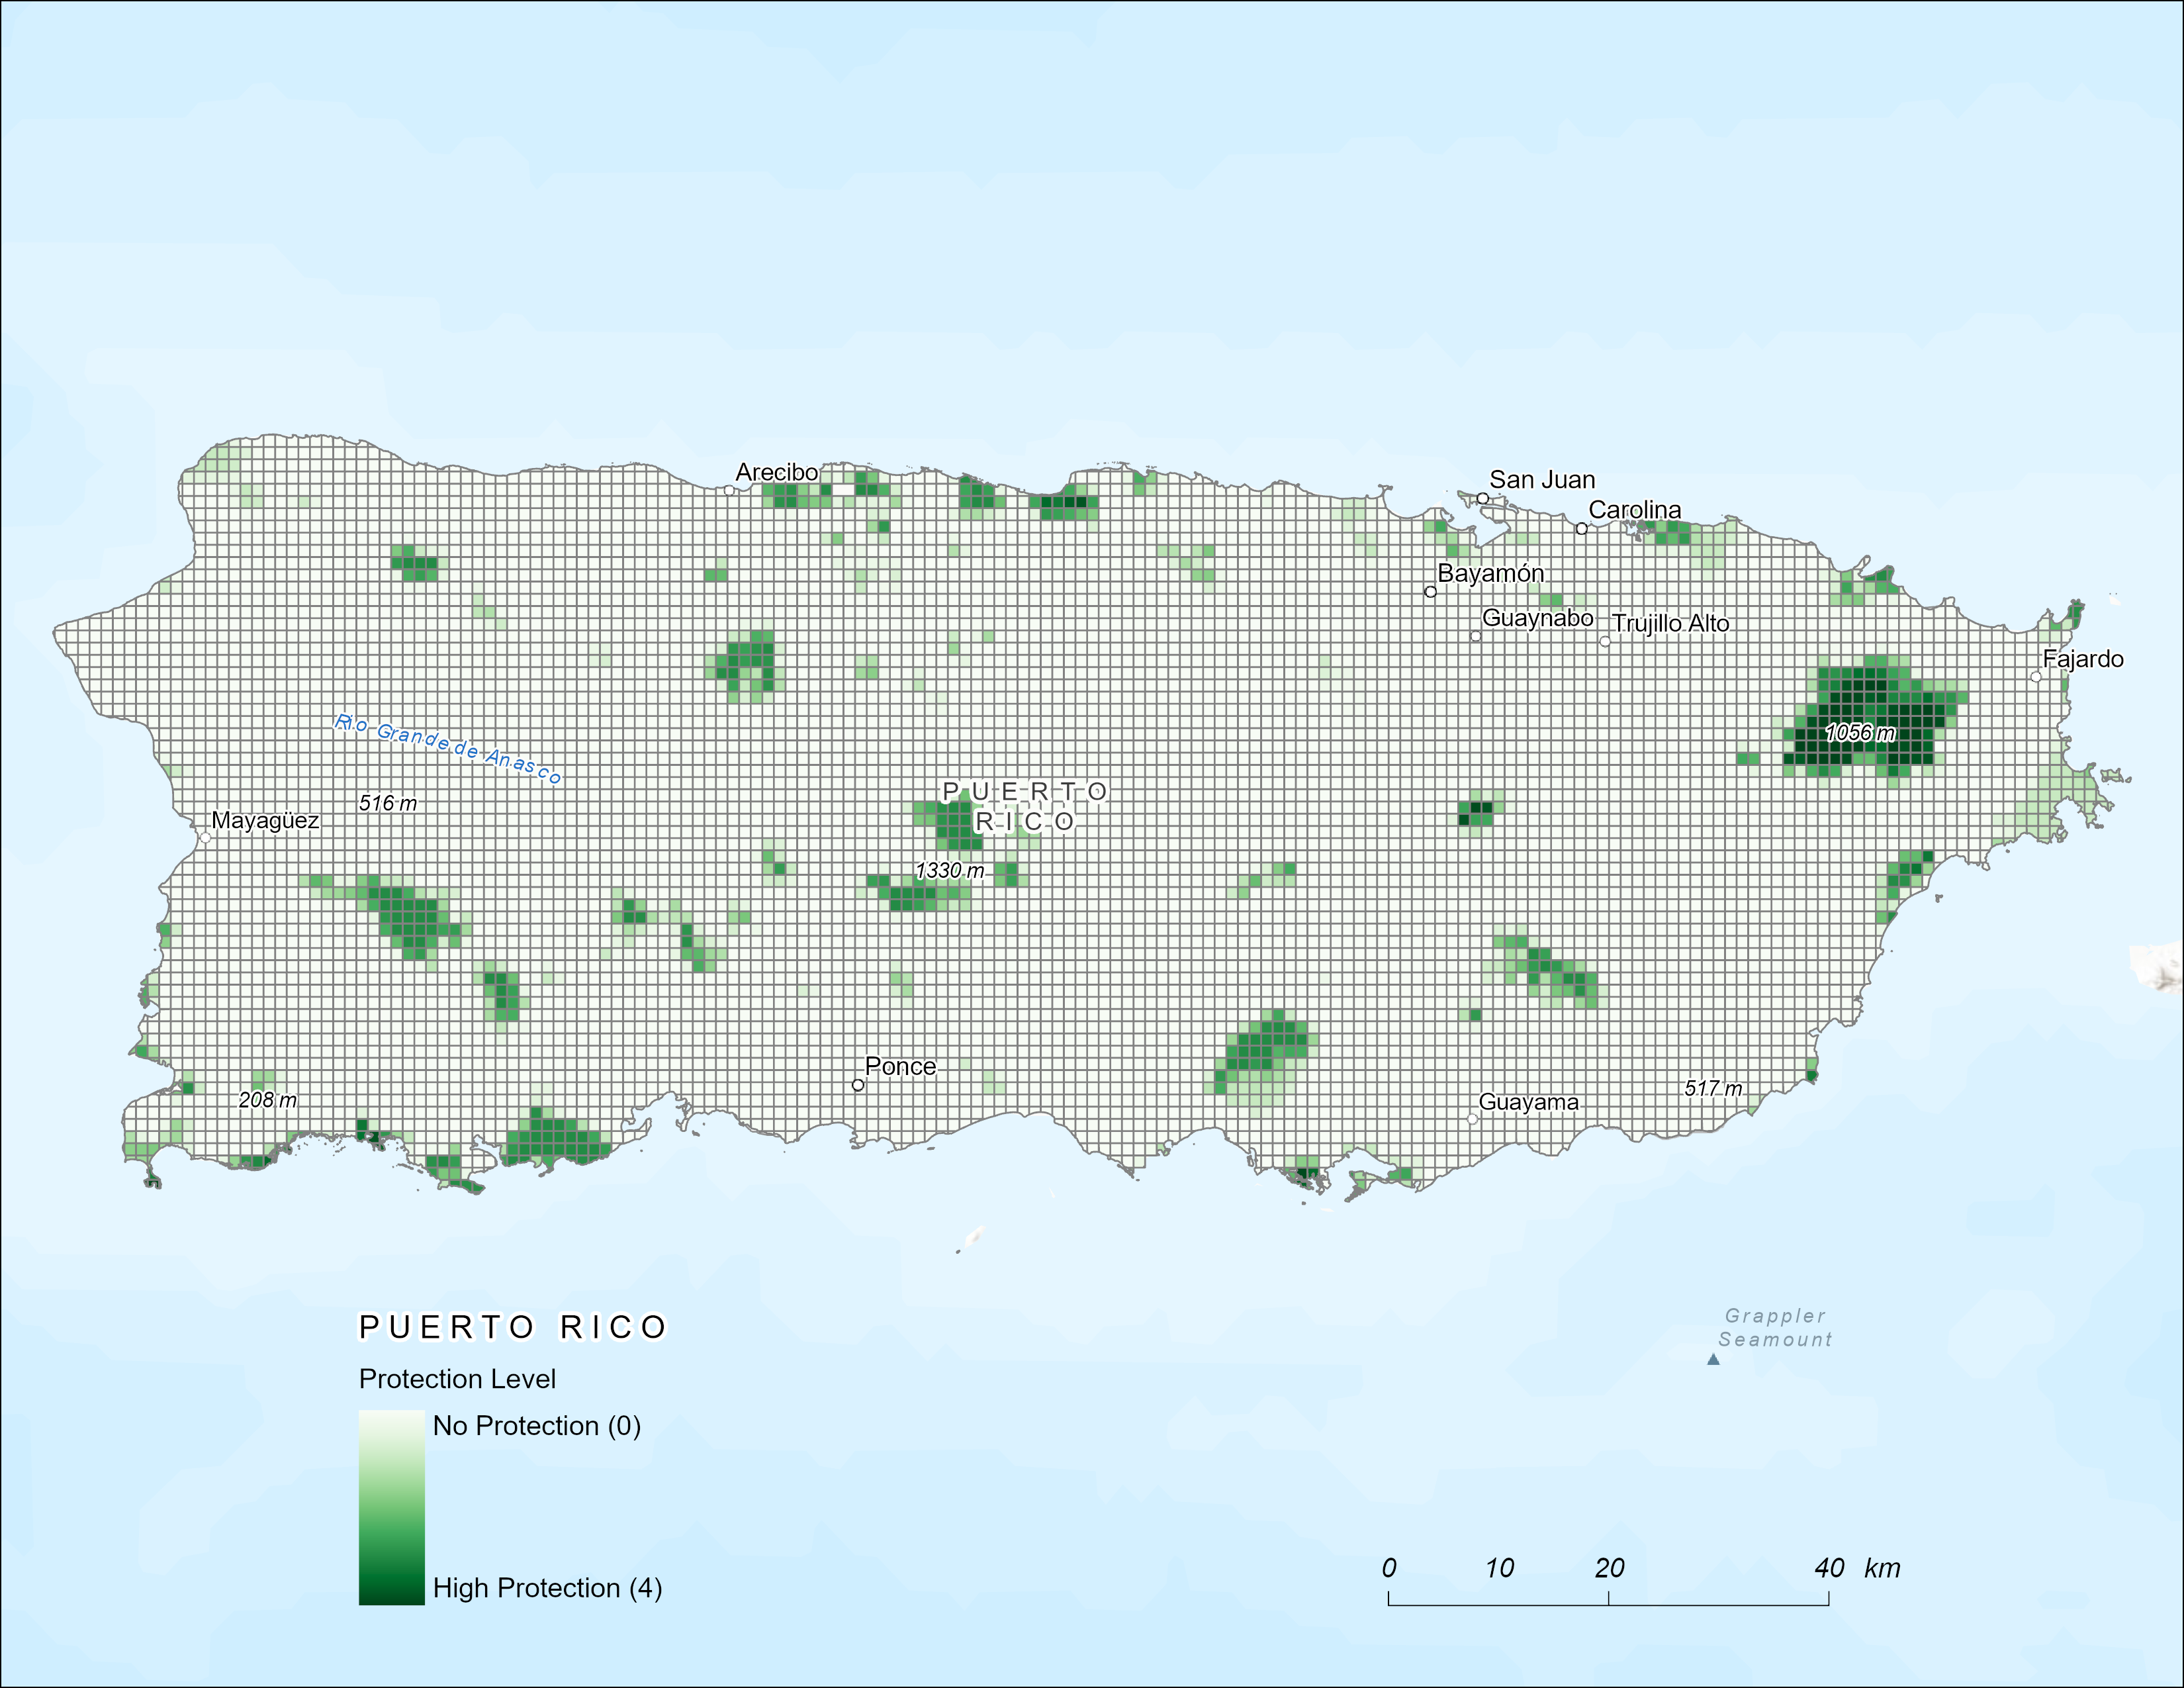

Figure 8. Forest Protection Level in Puerto Rico – 1 km.

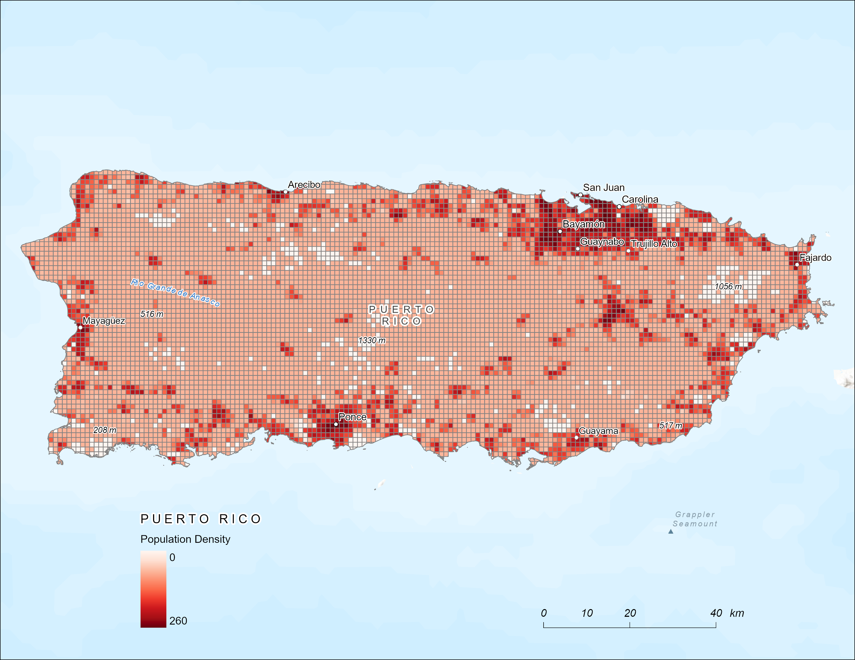

Figure 9. Population Density of Puerto Rico – 1 km.

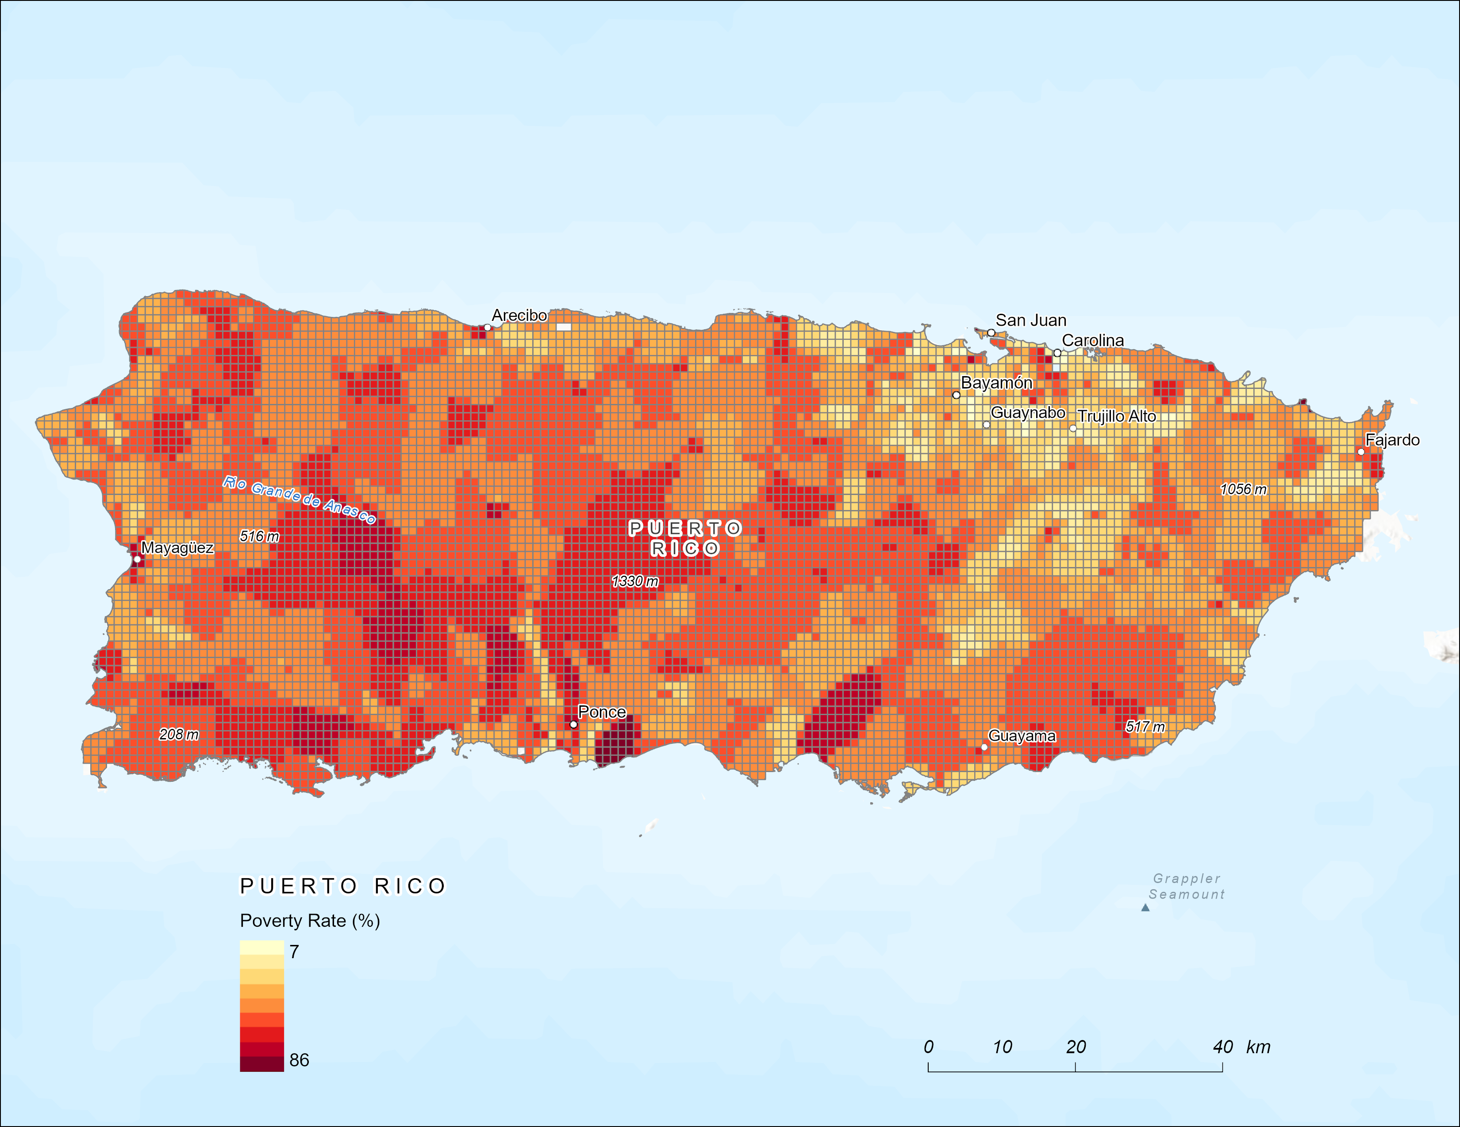

Figure 10. Poverty Rate in Puerto Rico – 1 km.

## Results

The results are shown in the figures below (see Figure 2 through Figure 7).

Results have found high Adjusted R-squared values at both the 1-km and 5-km scales implying up to 90% of the local variance can be explained by the model. The results should be interpreted with caution due to judgements made by the author when determining the explanatory variables of the model. Otherwise, the results suggest a strong influence and predictive potential of the slope, population, soil productivity, precipitation, poverty, and tree loss on the forest cover of Puerto Rico.

**Spatial Autocorrelation (Global Moran's)**

Spatial Autocorrelation (Global Moran's) was used to measure the spatial autocorrelation of forest cover by accounting for the nearest neighbor interactions (see Figure 11). In this situation, getting a "random" result is desires because it suggests that the residuals are independent of each other. This "random" result suggests that forest cover at one location in Puerto Rico is dependent on its surrounding forest cover.

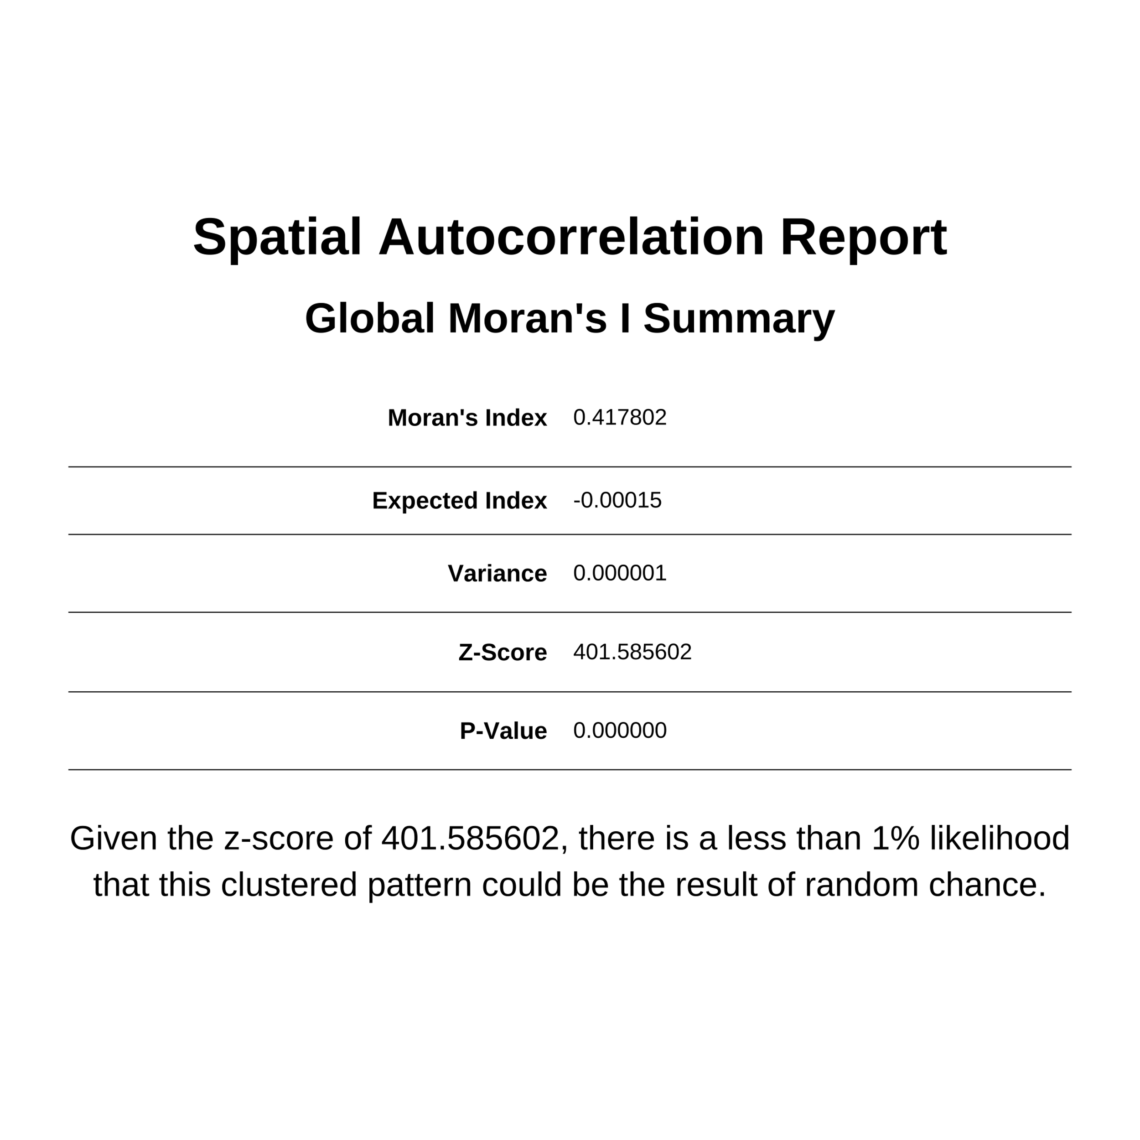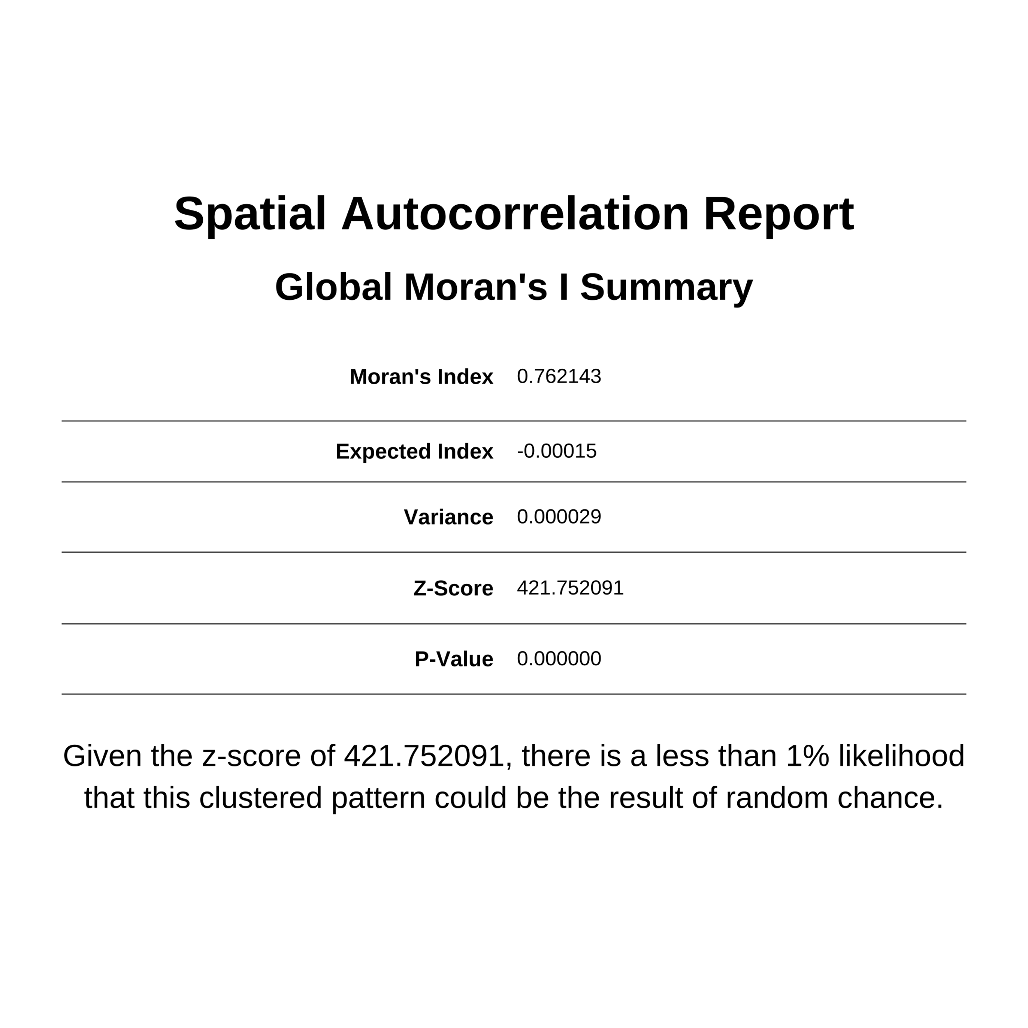

Figure 11. Spatial Autocorrelation Report – 1 km (Left); Spatial Autocorrelation Report – 5 km (Right).

**Hot Spot Analysis (Getis-Ord Gi)**

Hot Spot Analysis (Getis-Ord Gi) was used to identify if local areas of forest cover are significantly above or below the island's mean. The results of the Hot Spot Analysis are shown below in Figure 12. The areas marked as hot spots have a greater forest cover than the island's average whereas the cold spots have less forest cover than average.

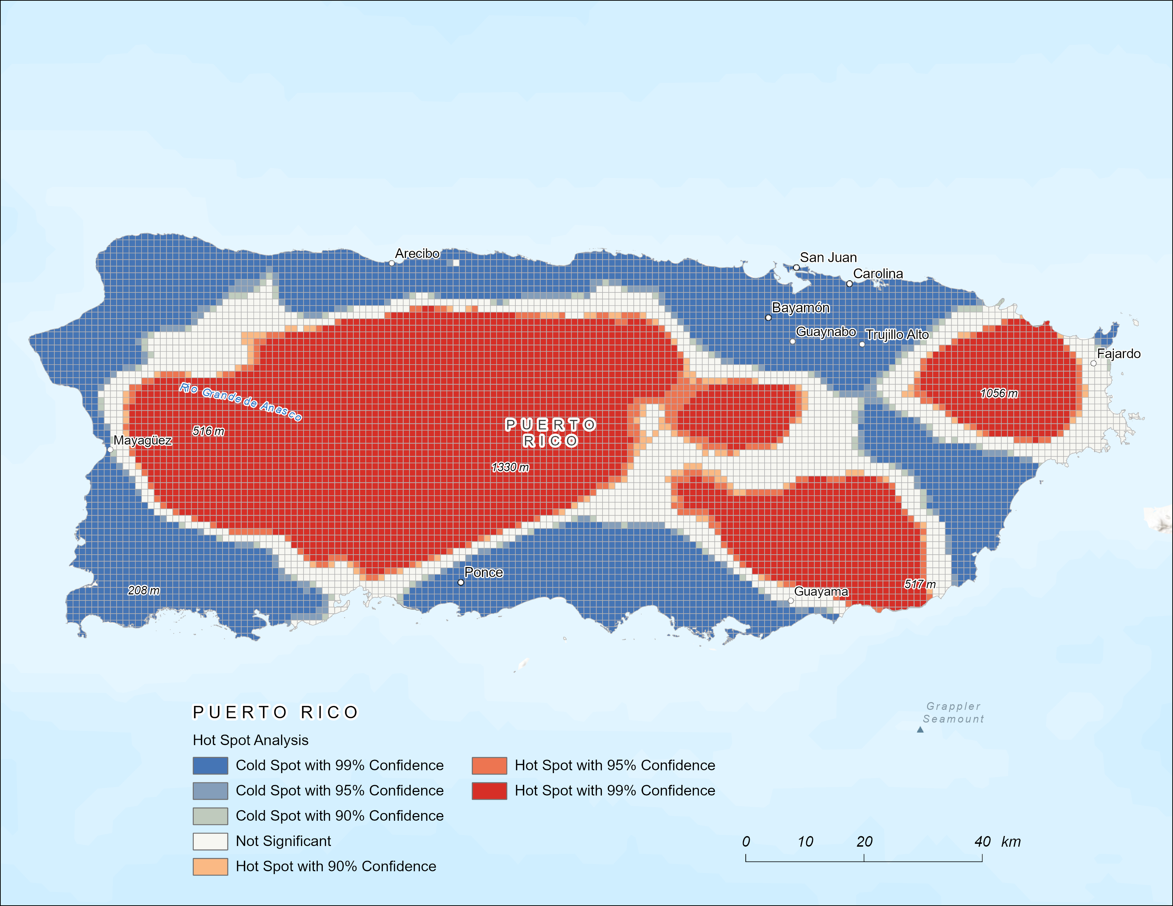

Figure 12. Hot Spot Analysis – 1 km.

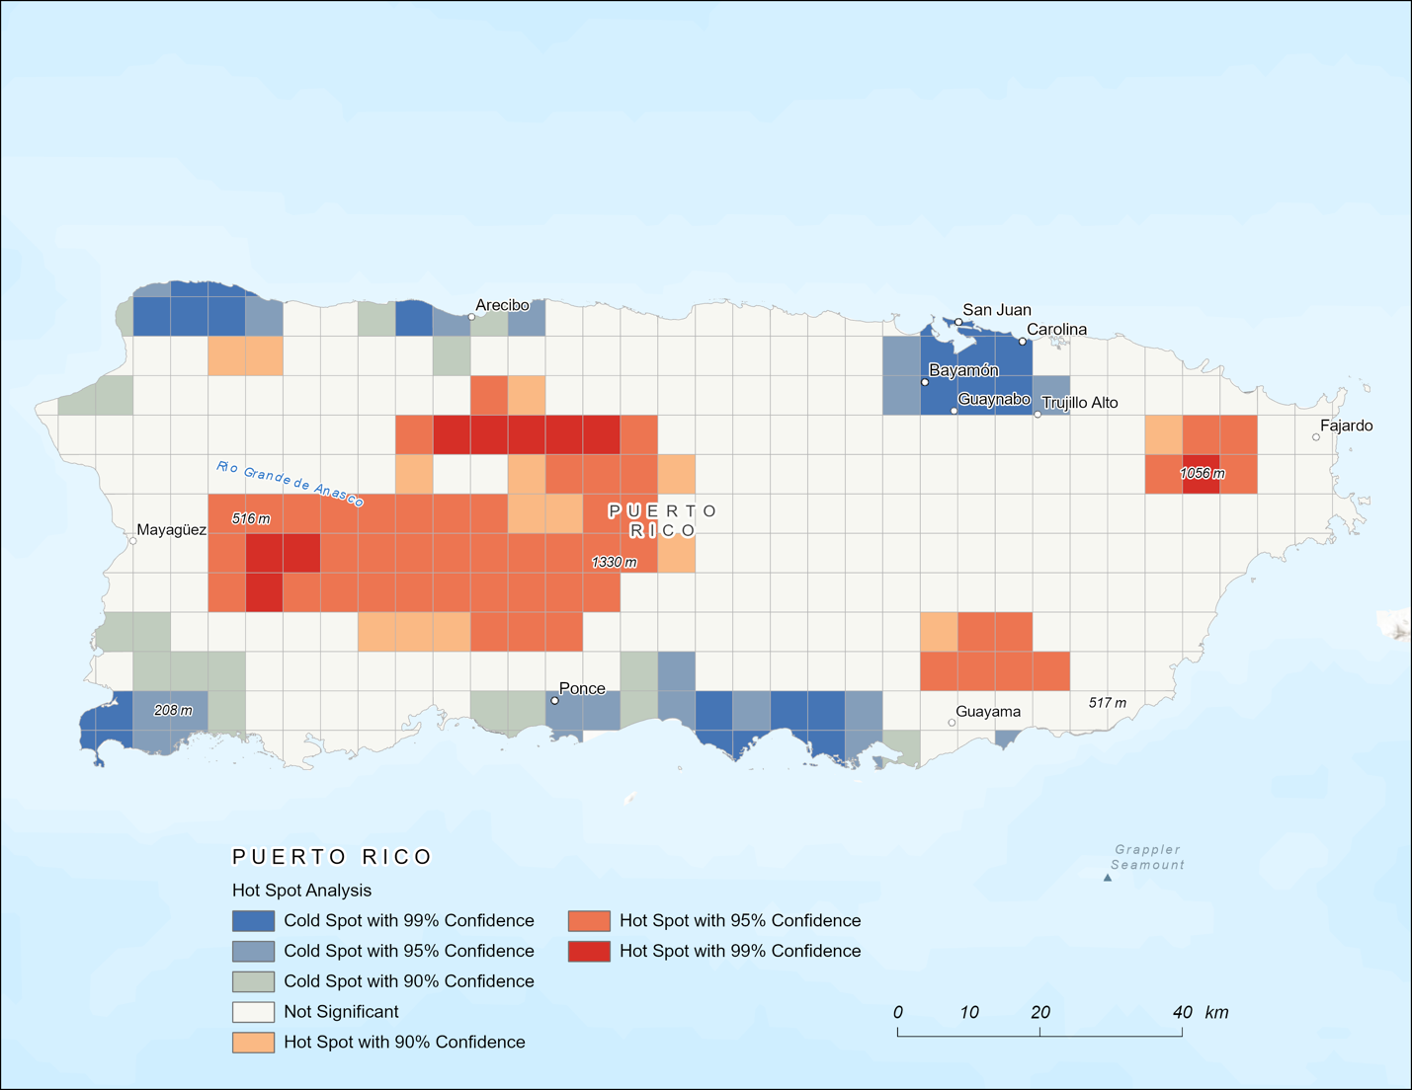

Figure 13. Hot Spot Analysis – 5 km.

**Geographically Weighted Regression (GWR)**

Geographically Weighted Regression (GWR) was used to determine the local relationships on a 1 km and 5 km scale. The high values outputted for both scales (see Figure 7) suggest that forest cover in Puerto Rico is strongly spatially patterned by the model factors. The strongest predictors for forest cover at a 1 km and 5 km scale were slope and soil productivity. Figures 15 and 16 depict the strong relationship slope and soil productivity have with forest cover at 1 km and 5 km.

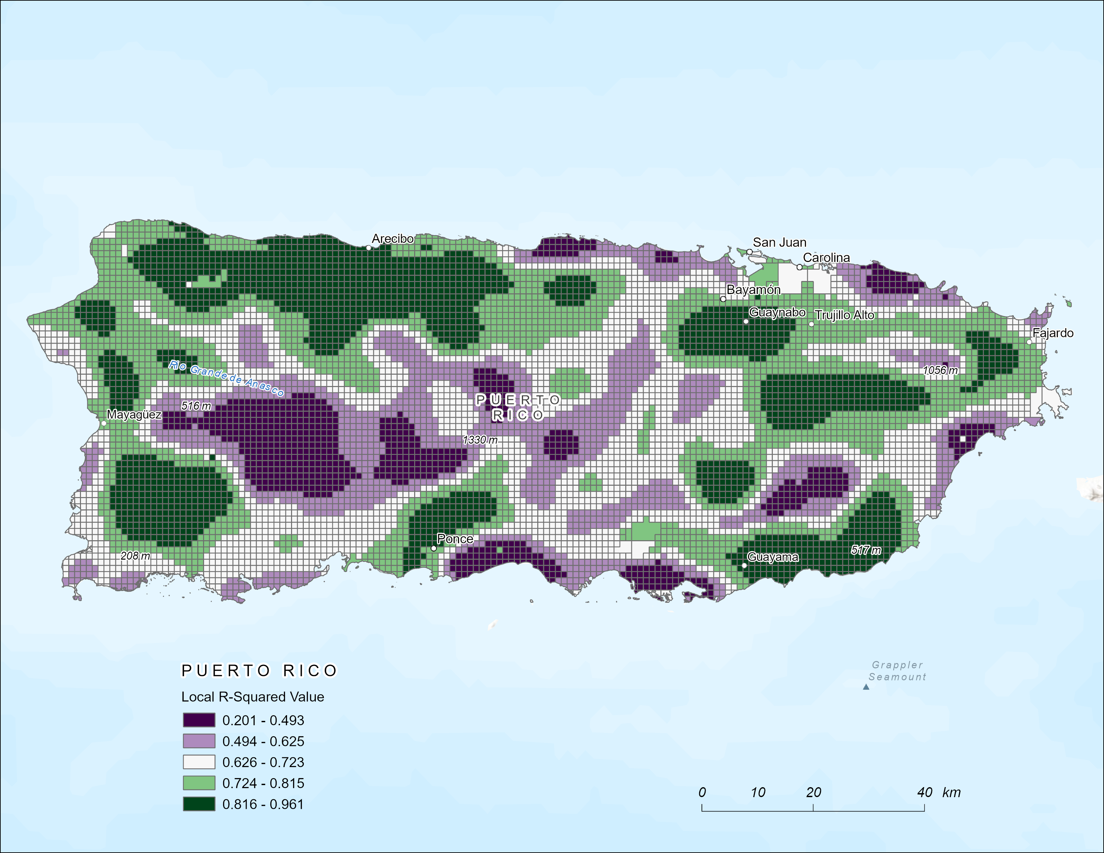

Figure 14. Local R-Squared Values – 1 km.

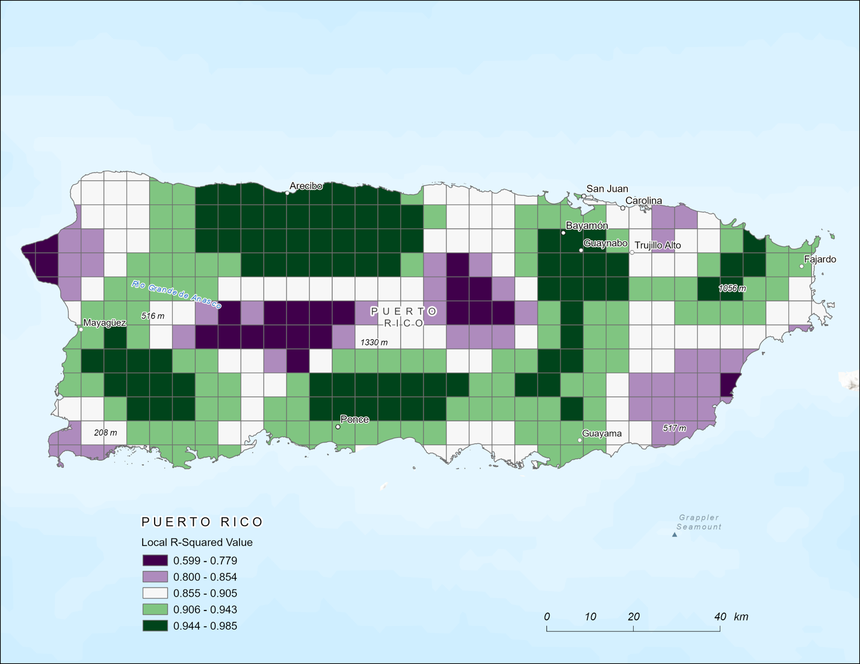

Figure 15. Local R-Squared Values – 5 km.

**Predicted Forest Cover**

Generalized Linear Regression (GLR) generated a predicted forest cover value for 2000 based on the explanatory variables chosen. The visualizations of the predicted forest cover values (shown in Figure 15) in comparison to the actual forest cover in 2000 (shown in Figure 17), show the efficacy of the model.

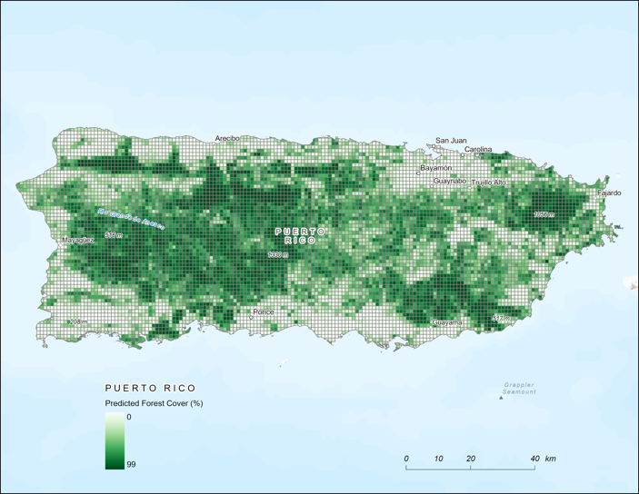 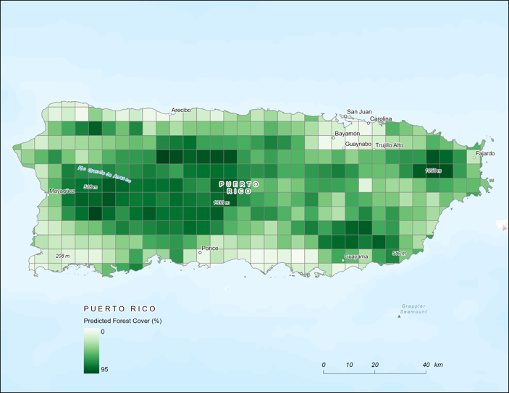

Figure 16. Predicted Forest Cover - 1 km (Left); Predicted Forest Cover - 5 km (Right).

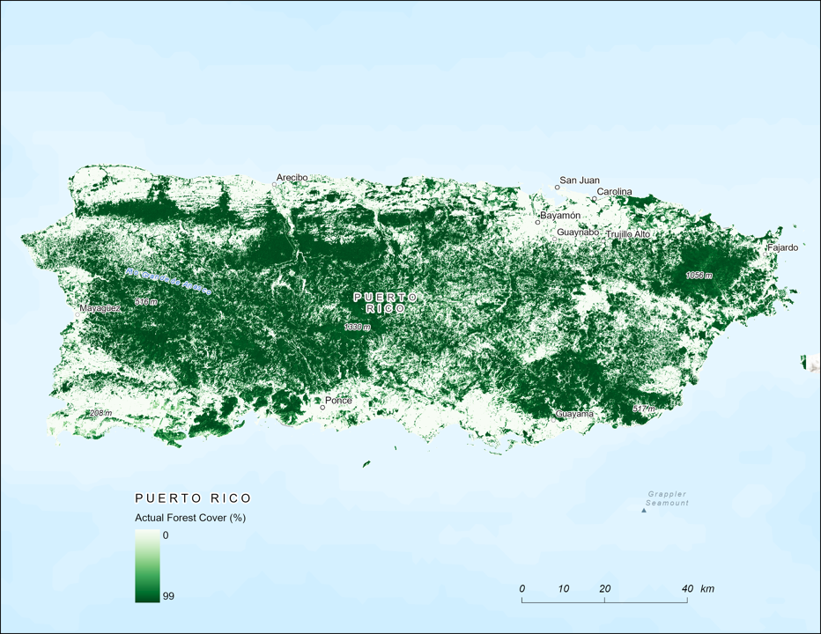

Figure 17. Actual Forest Cover - 1 km.

## 

Figure 18. Relationship between Slope and Forest – 5 km.

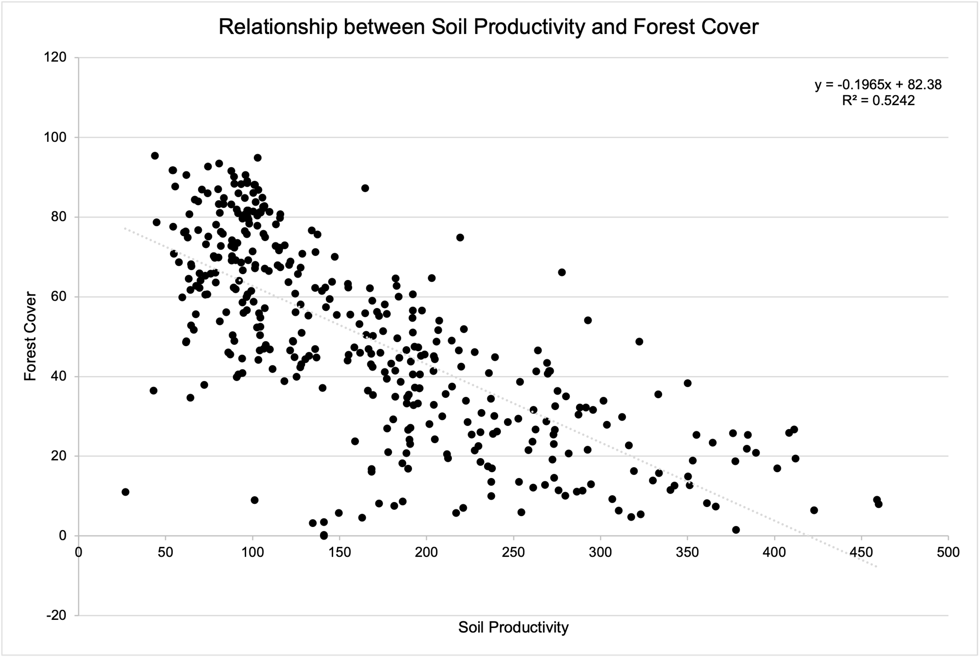

Figure 19. Relationship between Soil Productivity and Forest Cover – 5 km.

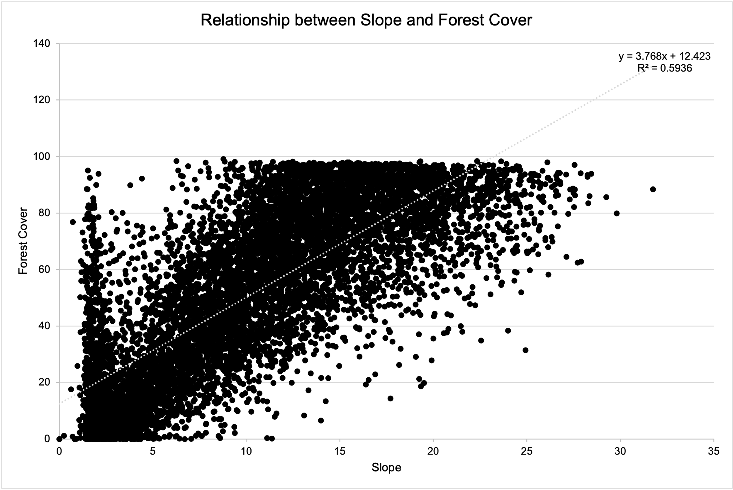

Figure 20. Relationship between Slope and Forest Cover – 1 km.

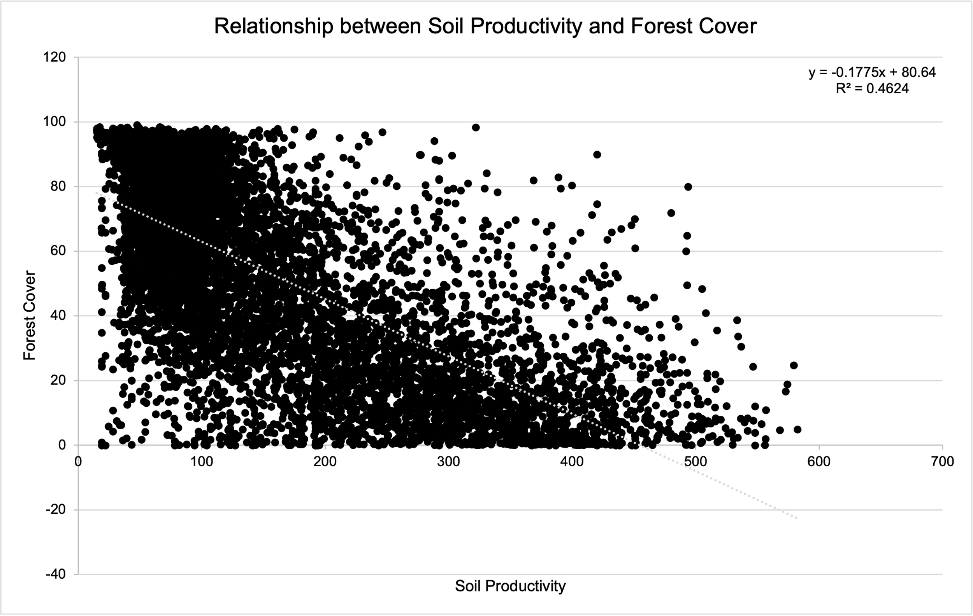

Figure 21. Relationship between Soil Productivity and Forest Cover – 1 km.

## Results Verification

The results will be verified qualitatively with a linear regression model.

# Discussion and Conclusion

While the objective was achieved, there are drawbacks to the results.

The available data was not comprehensive enough to run statistical model validation.

The model includes human dominated variables such as poverty and population. This shows no certainty in their significance across different study areas.

## References

Rudel, T. K., Perez-Lugo, M., & Zichal, H. (2000). When Fields Revert to Forest: Development and Spontaneous Reforestation in Post-War Puerto Rico. *The Professional Geographer*, *52*(3), 386–397. <https://doi.org/10.1111/0033-0124.00233>

Helmer, E., Ruzycki, T., Wilson, B., Sherrill, K., Lefsky, M., Marcano-Vega, H., Brandeis, T., Erickson, H., & Ruefenacht, B. (2018). Tropical Deforestation and Recolonization by Exotic and Native Trees: Spatial Patterns of Tropical Forest Biomass, Functional Groups, and Species Counts and Links to Stand Age, Geoclimate, and Sustainability Goals. *Remote Sensing*, *10*(11), 1724. <https://doi.org/10.3390/rs10111724>

## Self-score

|  |  |  |  |
| --- | --- | --- | --- |
| **Category** | **Description** | **Points Possible** | **Score** |
| **Structural Elements** | All elements of a lab report are included **(2 points each)**:  Title, Notice: Dr. Bryan Runck, Author, Project Repository, Date, Abstract, Problem Statement, Input Data w/ tables, Methods w/ Data, Flow Diagrams, Results, Results Verification, Discussion and Conclusion, References in common format, Self-score | 28 | **27** |
| **Clarity of Content** | Each element above is executed at a professional level so that someone can understand the goal, data, methods, results, and their validity and implications in a 5 minute reading at a cursory-level, and in a 30 minute meeting at a deep level **(12 points)**. There is a clear connection from data to results to discussion and conclusion **(12 points)**. | 24 | **22** |
| **Reproducibility** | Results are completely reproducible by someone with basic GIS training. There is no ambiguity in data flow or rationale for data operations. Every step is documented and justified. | 28 | **26** |
| **Verification** | Results are correct in that they have been verified in comparison to some standard. The standard is clearly stated **(10 points)**, the method of comparison is clearly stated **(5 points)**, and the result of verification is clearly stated **(5 points)**. | 20 | **18** |
|  |  | 100 | **93** |